**Components List**

**Arduino mega 2560R3 – Microcontroller**

* It is the brain of the device
* ATmega2560 with 256 KB of flash memory, 8 KB of SRAM, and 4 KB of EEPROM
* Microcontrollers store their program code in flash memory
* 54 I/O pins -connect a variety of sensors ,acutators and other devices.
* Serial ports-easy communication with multiple devices like Bluetooth modules,Gps receivers..
* Cost-Arduino Mega 2560R3 for around ₹1,475 to ₹2,000 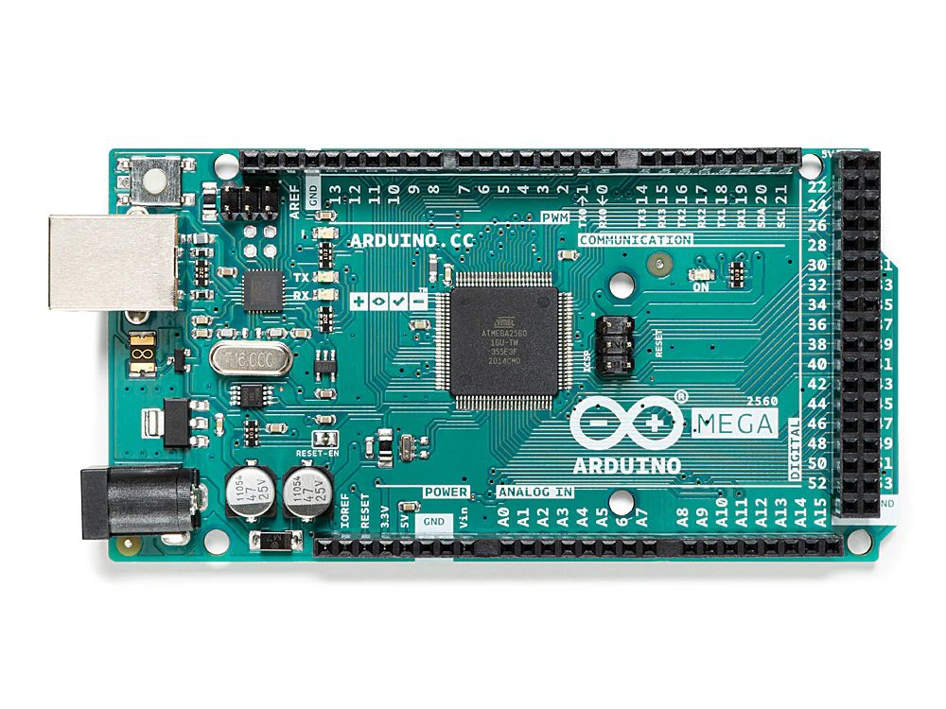

**DS 3231 precision RTC break out**

* The DS3231 Precision Real-Time Clock (RTC) Breakout Board is a highly accurate and reliable timekeeping device that provides precise date and time information
* The DS3231 chip offers a timekeeping accuracy of ±2 ppm over the temperature range of -40°C to +85°C.
* **Data Loggers:** Timestamping data points for precise time-based recording.
* **Cost-DS3231 RTC board for around ₹200 to ₹400**

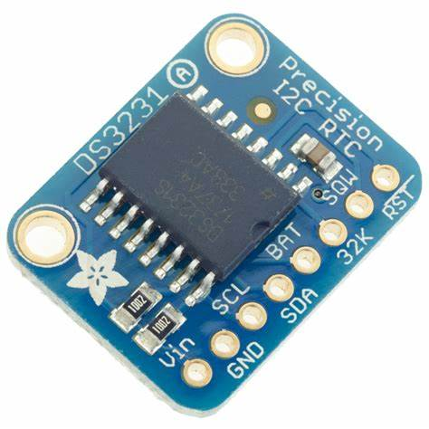

**NEO-6M GPS module**

* It provides accurate positioning information.
* **Satellite Acquisition:** The NEO-6M searches for GPS satellites in the sky by listening for their signals. The module calculates time it takes for the signal to travel from the satellite to the receiver.
* **Triangulation:** By measuring the time difference between signals from multiple satellites, the module can triangulate its position on the Earth's surface.
* **Data Processing**: The module processes the GPS data to calculate latitude, longitude, altitude, speed, and other relevant information.
* **Output:** The GPS data is typically output in NMEA format, which is a standardized way of representing GPS data. Thisdata can be read by a microcontroller or other device to be used for navigation or other applications.
* NEO-6M GPS module for around **₹300 to ₹500**

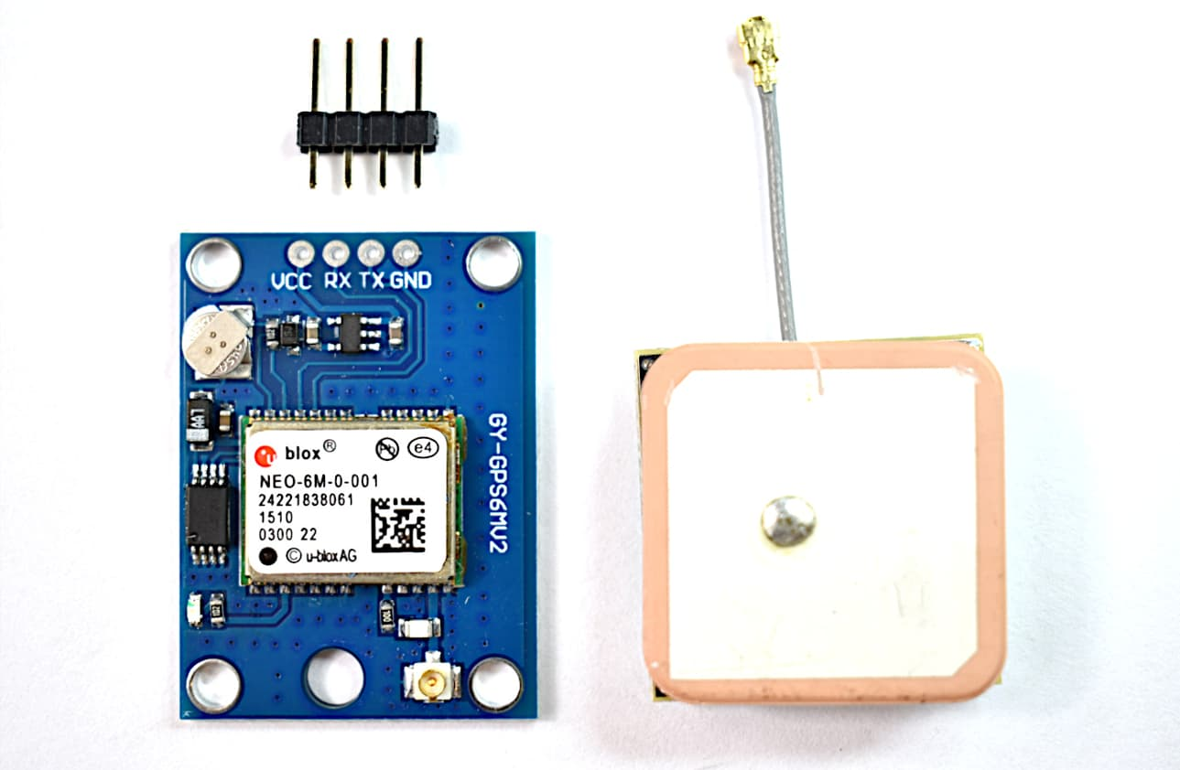

**OLED Displays :**

* OLED-Organic light-emitting diode
* Size-1.3 inch 128*68 cm
* Mainly used in smart phones ,smart watches, televisions …
* OLED displays utilize the electroluminescence of organic materials to produce light.
* This means that when an electric current is applied to these materials, they emit light.
* OLED displays use a combination of red, green, and blue (RGB) sub-pixels to create different colors. By controlling the intensity of eachpixel, the display can produce a wide range of colors.

## 

**Accelerometer and TempLSM 9DS1**

* **Accelerometer**: The accelerometer measures the force of acceleration acting on the device. This can be used todetermine the device's orientation, movement, or vibration**.**
* The LSM9DS1 is a 9-axis inertial measurement unit (IMU) that combines a 3-axis accelerometer, 3-axis gyroscope, and 3-axis magnetometer into a single chip.
* 3-Axis Accelerometer: Measures linear acceleration along the x, y, and z axes.
* 3-Axis Gyroscope: Measures angular velocity around the x, y, and z axes.
* 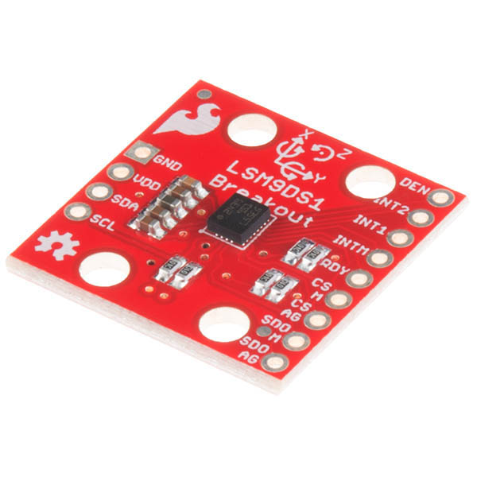3-Axis Magnetometer: Measures the Earth's magnetic field strength along the x, y, and z axes.
* Cost- LSM9DS1 for around **₹400 to ₹800**

**GPRS and GSM SIM800L**

* SIM800L is a GSM/GPRS module that provides cellular connectivity for various applications. It supports both GSM (2G) and GPRS (2.5G networks, allowing for voice calls, SMS messaging, and data transmission.
* It's widely used in IoT devices, tracking systems, and other projects that require communication over cellular networks.
* SIM800L for around **₹400 to ₹800**

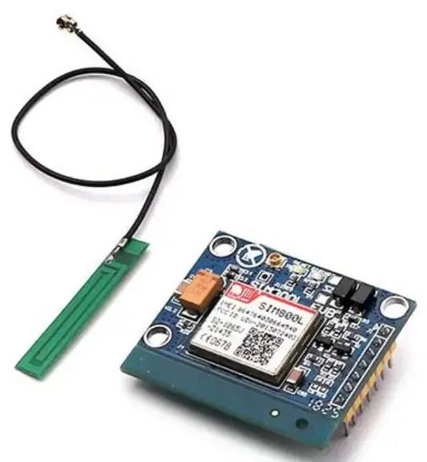

**Lithium polymer battery**

* A 7.4V lithium polymer battery, also known as a 2S LiPo battery, consists of two 3.7V lithium polymer cells connected in series.
* **Charging:** When a 7.4V LiPo battery is charged, lithium ions move from the anode to the cathode**(lithium cobalt oxide ).**
* **Discharging:** When the battery is discharged, lithium ions move from the cathode back to the anode(**graphite**), releasing energy.
* 7.4V lithium polymer batteries ranging from **₹500 to ₹5,000**

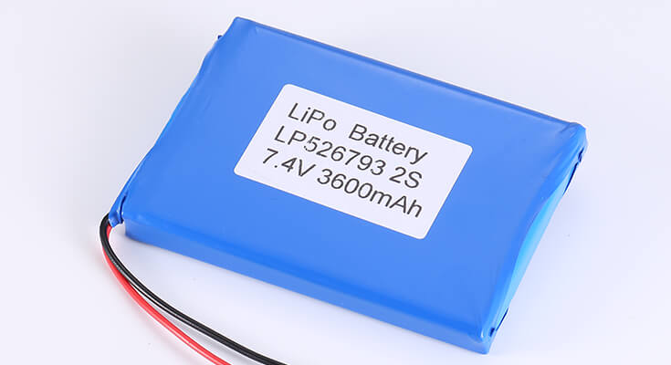

**AM2302 Humidity and Temperature Sensors**

* The AM2302 is a digital temperature and humidity sensor that provides accurate measurements of both temperature and relative humidity.
* **Temperature Measurement:** The AM2302 uses a capacitive sensor to measure temperature. The capacitance of the sensor changes with temperature, allowing for accurate measurement.
* In the range of -40°C to +80°C with a resolution of 0.1°C.
* **Humidity sensor:**Measueres the relative humidity in the atmosphere
* In the range from 0% to 100% RH
* Cost-AM2302 Humidity and Temperature Sensors **₹150 to ₹400**.

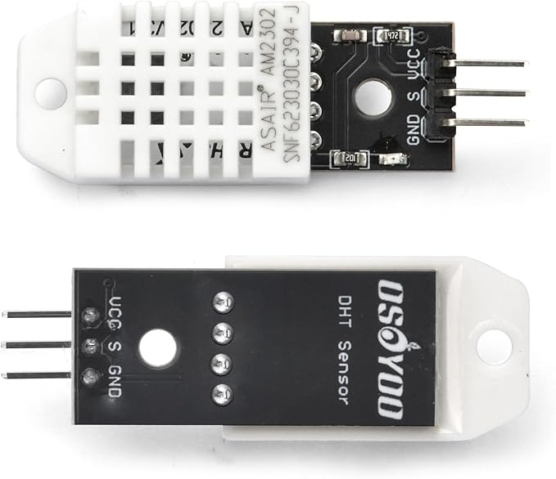

**Vibration Motor**

* **A vibration motor** is a small, electric motor that generates vibrations. It's commonly used in devices like smartphones, game controllers, and wearable technology to provide tactile feedback or alerts.
* **Smartphones and Tablets:** For tactile feedback and alerts.
* **Cost –** Vibration motor from **₹150 to ₹200.**

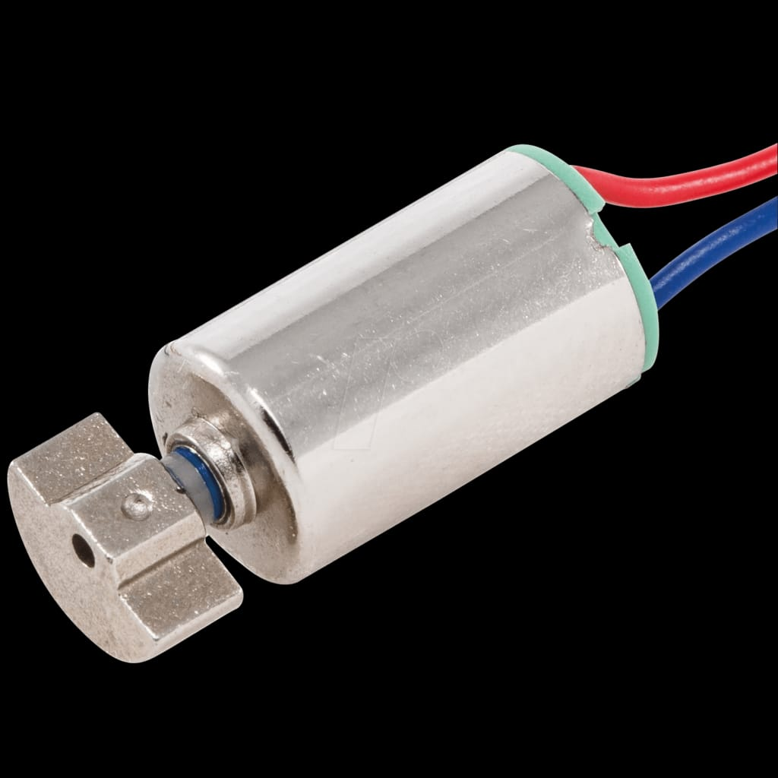

**Heart rate pulse sensor**

* A heart rate pulse sensor is a device used to measure a person's heart rate by detecting the changes in blood flow beneath the skin. These changes are often detected as pulses or vibrations.
* Cost – Heart rate pulse sensor from **₹150 to ₹200**

